# 1 准备数据和文档

网赚SDK接入文档

<https://note.youdao.com/s/5CzhMAN9>

数数key：e329d714246744bd9901ad384b235e0b  
数数url：[https://dataa.piggerworld.com](https://dataa.piggerworld.com/" \t "https://app.slack.com/client/T03C22UV8G4/_blank)  
af key：WL4MYAw9MwaBoXTE4pmvrg

Web Client ID：783094220366-f2hhp1q3cjaksme49iqrlq1l2ereku56.apps.googleusercontent.com

## APP名称 Piggy World

\launcher\src\main\res\values\strings.xml

|  |
| --- |
| <?xml version="1.0" encoding="utf-8"?> <resources>  <string name="app_name">Piggy World</string>  <string name="game_view_content_description">Game view</string> </resources> |

## 游戏包名com.piggerworld.earncash

com.piggerworld.earncash

旧的包名 com.goldenhouse.earn

E:\_google_play\as_pig_2022\launcher\build.gradle

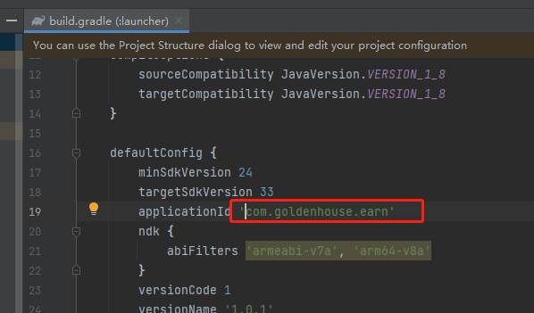

E:\_google_play\as_pig_2022\launcher\src\main\AndroidManifest.xml

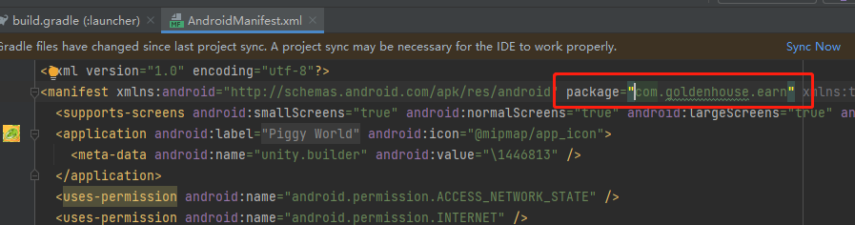

## Package Name

### Unity

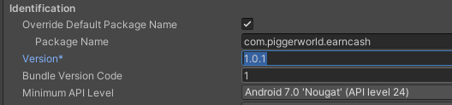

### Android Studio

E:\_google_play\as_pig_2022\launcher\build.gradle

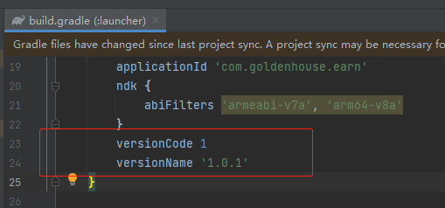

# App Icon

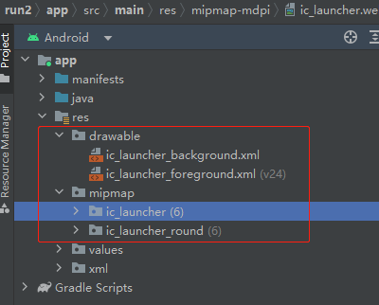

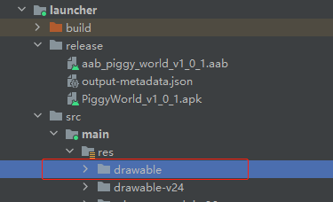

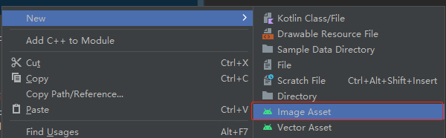

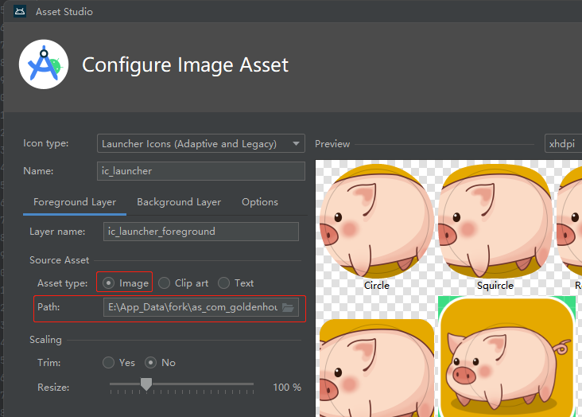

## Icon app_icon.png

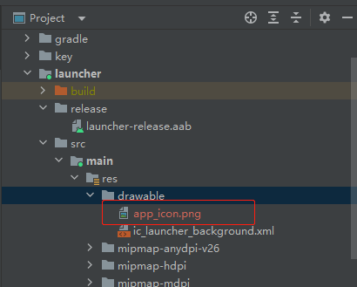

<application android:label="@string/app_name" android:icon="@drawable/app_icon">  
 <meta-data android:name="unity.builder" android:value="\1446813" />  
</application>

# aab发布商店记录

release_piggerworld_v1_0_1.aab

# 签名文件

## 上架需要你修改一下谷歌的默认签名

$ java -jar pepk.jar --keystore=foo.keystore --alias=foo --output=output.zip --include-cert --encryptionkey=eb10fe8f7c7c9df715022017b00c6471f8ba8170b13049a11e6c09ffe3056a104a3bbe4ac5a955f4ba4fe93fc8cef27558a3eb9d2a529a2092761fb833b656cd48b9de6a

|  |
| --- |
| PS E:\android_tools> java -version  openjdk version "11.0.12" 2021-07-20  OpenJDK Runtime Environment Microsoft-25199 (build 11.0.12+7)  OpenJDK 64-Bit Server VM Microsoft-25199 (build 11.0.12+7, mixed mode)  PS E:\android_tools> |

## 在同一个目录执行命令

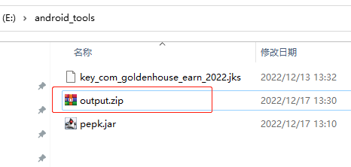

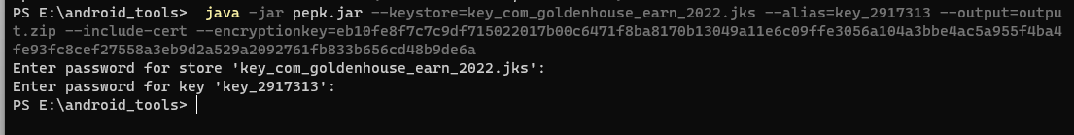

|  |
| --- |
| PS E:\android_tools> java -jar pepk.jar --keystore=key_com_goldenhouse_earn_2022.jks --alias=key_2917313 --output=output.zip --include-cert --encryptionkey=eb10fe8f7c7c9df715022017b00c6471f8ba8170b13049a11e6c09ffe3056a104a3bbe4ac5a955f4ba4fe93fc8cef27558a3eb9d2a529a2092761fb833b656cd48b9de6a |

# 签名配置

E:\App_Data\fork\as_com_goldenhouse\unityLibrary\build.gradle

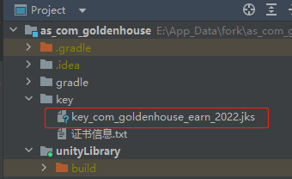

signingConfigs **{** release **{** storeFile file('../key/key_com_goldenhouse_earn_2022.jks')  
 storePassword '2917313'  
 keyAlias 'key_2917313'  
 keyPassword '2917313'  
 **}  
}**

# Facebook Login

# Google Login

# Android Studio 接入.aar

## 把要引入的外部插件复制到app/libs

E:\_google_play\as_pig_2022\unityLibrary\libs

# 替换项目Unity文件

<https://gitee.com/usfem/as_com_goldenhouse.git>

[git@gitee.com:usfem/as_com_goldenhouse.git](mailto:git@gitee.com:usfem/as_com_goldenhouse.git)

## symbols

路径 \as_com_goldenhouse\unityLibrary

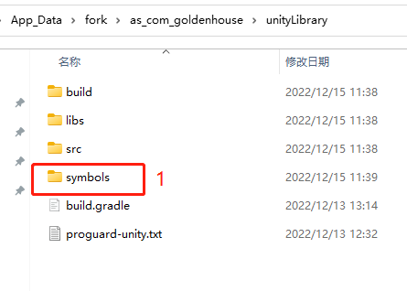

## 资源和功能

路径 \as_com_goldenhouse\unityLibrary\src\main

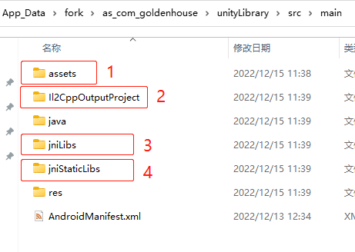

## Launcher res

as_com_goldenhouse\launcher\src\main\res

# Settings-Android Studio

## 1

E:\App_Data\fork\as_com_goldenhouse\gradle.properties

android.useAndroidX=true  
android.enableJetifier=true

## 2

|  |
| --- |
| Caused by: org.gradle.api.internal.artifacts.ivyservice.DefaultLenientConfiguration$ArtifactResolveException: Could not resolve all files for configuration ':launcher:debugRuntimeClasspath'. |

引用的库没下载完。

## 3 adjoe.io/adjoe-sdk/

<https://docs.adjoe.io/adjoe-sdk/>

|  |
| --- |
| Could not find io.adjoe:adjoe-sdk-android:2.0.4.  Required by:  project :unityLibrary  Search in build.gradle files |

什么是adjoe SDK？

adjoe SDK 将允许您将我们的广告格式集成到您的应用程序中，从而轻松有效地通过您的影响力获利。

“Playtime”是一种独特的广告形式，奖励安装并持续使用我们广告合作伙伴的应用程序的用户。点击 Playtime 提要中显示的任何广告都会将用户带到 Play 商店。通过玩这个广告应用，用户可以在您的应用中获得奖励——他们玩的越多，赚的越多！而且，当然，您还可以从您应用的用户产生的每次安装中获利。

# 分享好友

## 链接

分享是标准的google 分享链接类似这种  
[https://play.google.com/store/apps/details?id=com.piggerworld.earncash&referrer=utm_source=361](https://play.google.com/store/apps/details?id=com.piggerworld.earncash&referrer=utm_source=361" \t "https://app.slack.com/client/T03C22UV8G4/_blank)

你拿到我们的文案以后把这个下载链接拼上去就行

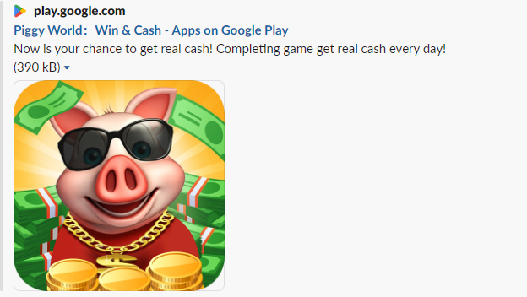

# 邀请好友

邀请是gb下载链接➕文案，文案我们根据国家给你下发，下载链接的话你们拼一下就行

分享和邀请好友是同一个功能点。都是走SDK

# FB登录

<https://developers.facebook.com/docs/facebook-login/android>

## 生成bash

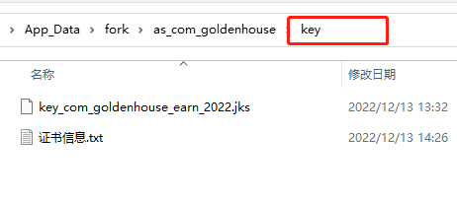

com.unity3d.player.UnityPlayerActivity

选中路径后，输入CMD ，回车：

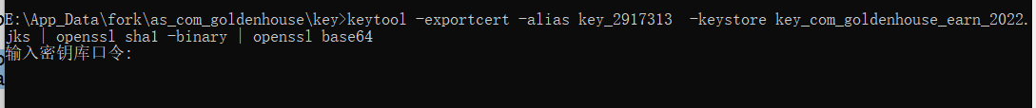

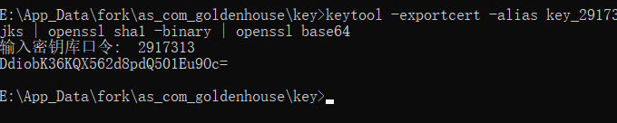

|  |
| --- |
| key>keytool -exportcert -alias key_2917313 -keystore key_com_goldenhouse_earn_2022.jks | openssl sha1 -binary | openssl base64 |

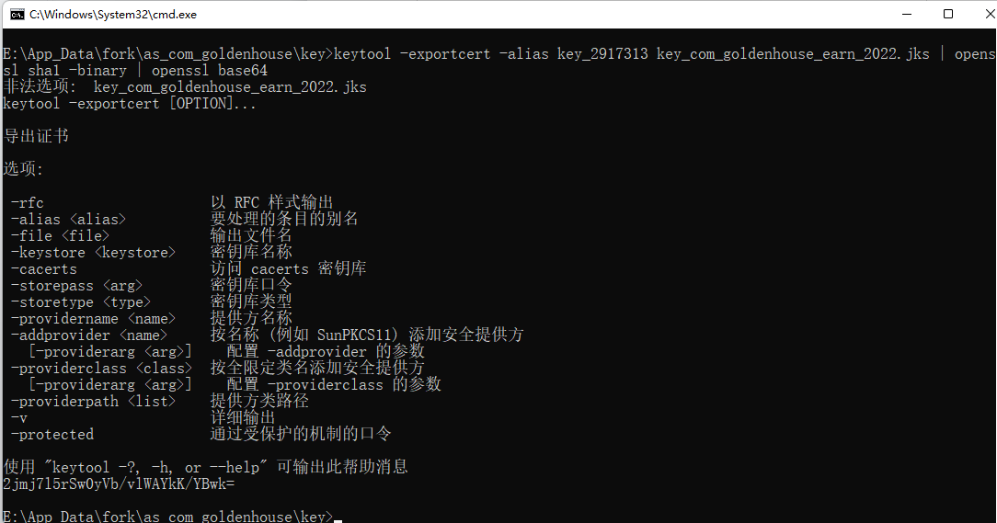

# Google

|  |
| --- |
| $ java -jar pepk.jar --keystore=foo.keystore --alias=foo --output=output.zip --include-cert --encryptionkey=eb10fe8f7c7c9df715022017b00c6471f8ba8170b13049a11e6c09ffe3056a104a3bbe4ac5a955f4ba4fe93fc8cef27558a3eb9d2a529a2092761fb833b656cd48b9de6a |

Foo.jks 也可以

pepk.jar

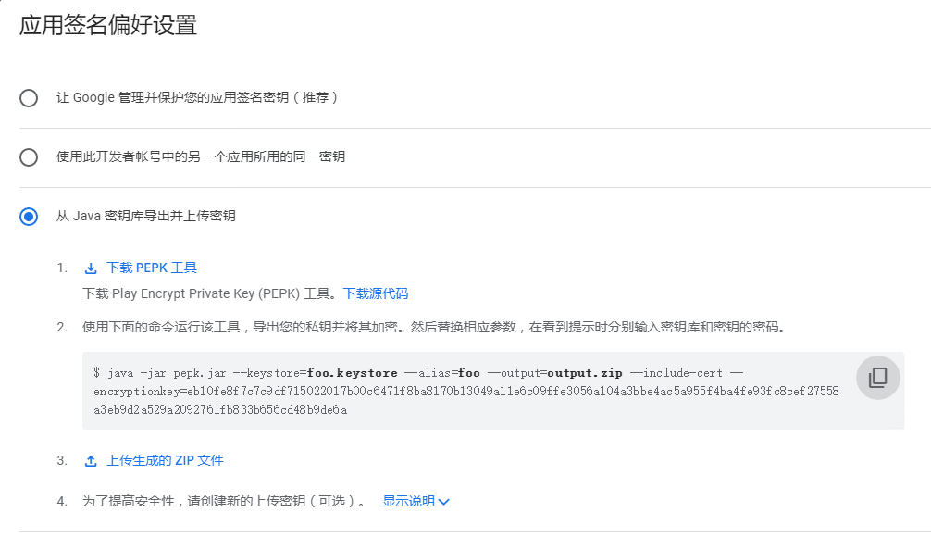

# 日志

google_login_success=rU0fYeD_DVj_D_QbPOL_G

public void login(Context context) {  
 // 设置登录结果回调  
 CoreAbility.*getInstance*().setOnLoginListener(new OnLoginListener() {  
 @Override  
 public void onLogin(String token) {  
 Unity_LoginSuccess(token);  
 Log.*d*(*TAG*, "google_login_success=" + token  
 );  
 }  
  
 @Override  
 public void onLogout() {  
 Unity_Logout("on_logout");  
 Log.*d*(*TAG*, "onLogout");  
 }  
 });  
 CoreAbility.*getInstance*().redirectActivity(context, CoreEntrance.*LOGIN*);  
}

# Error list

## 1 有Unity APP黑色顶部条

### 旧的样式文件

|  |
| --- |
| <?xml version="1.0" encoding="utf-8"?>  <resources>      <style name="UnityThemeSelector" parent="BaseUnityTheme">          <item name="android:windowBackground">@android:color/black</item>      </style>      <style name="BaseUnityTheme" parent="android:Theme.Holo.Light.NoActionBar.Fullscreen"></style>      <style name="UnityThemeSelector.Translucent" parent="@style/UnityThemeSelector">          <item name="android:windowIsTranslucent">true</item>          <item name="android:windowBackground">@android:color/transparent</item>      </style>      <style name="AppTheme" parent="Theme.AppCompat.Light.NoActionBar"></style>  </resources> |

### 修改后的

|  |
| --- |
| <?xml version="1.0" encoding="utf-8"?> <resources>  <style name="UnityThemeSelector" parent="BaseUnityTheme">  <item name="android:windowBackground">@android:color/black</item>  </style>  <style name="BaseUnityTheme" parent="android:Theme.Holo.Light.NoActionBar.Fullscreen"></style>  <style name="UnityThemeSelector.Translucent" parent="@style/UnityThemeSelector">  <item name="android:windowIsTranslucent">true</item>  <item name="android:windowBackground">@android:color/transparent</item>  </style>  <style name="AppTheme" parent="Theme.AppCompat.Light.NoActionBar"></style> </resources> |

### 修改的地方

   <style name="BaseUnityTheme" parent="android:Theme.Holo.Light.NoActionBar.Fullscreen"></style>

<style name="AppTheme" parent="Theme.AppCompat.Light.NoActionBar"></style>

## 2 删除APP下各个模块下的build目录

## 3 BuildConfig 被定义了多次

|  |
| --- |
| Type com.piggerworld.earncash.BuildConfig is defined multiple times: E:\App_Data\fork\as_com_goldenhouse\launcher\build\intermediates\project_dex_archive\release\out\com\piggerworld\earncash\BuildConfig.dex, E:\App_Data\fork\as_com_goldenhouse\unityLibrary\build\.transforms\5de782a0f9cb03828a311caf7650f77b\transformed\release\com\piggerworld\earncash\BuildConfig.dex |

Caused by: com.android.tools.r8.CompilationFailedException: Compilation failed to complete, origin: E:\App_Data\fork\as_com_goldenhouse\launcher\build\intermediates\project_dex_archive\release\out\com\piggerworld\earncash\BuildConfig.dex

## 4 尚未完成Google 验证流程

